

A Widget by James M. Allen

Quick Overview
The object of Jumbalaya is to earn points by making words out of a given set of letters. Earn enough points to move on to the next round to continue earning points!

Acknowledgements
This Widget was a birthday present for my wife, who loves me (almost) as much as she loves word games.

How to Play
To start playing, click on the “New Game” button when the Widget starts up.
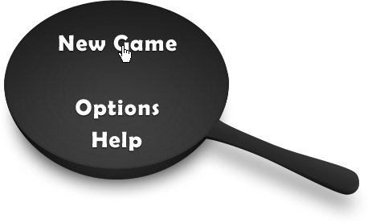
Quick! Now type all the words you can think of that contain the letters in the pan!
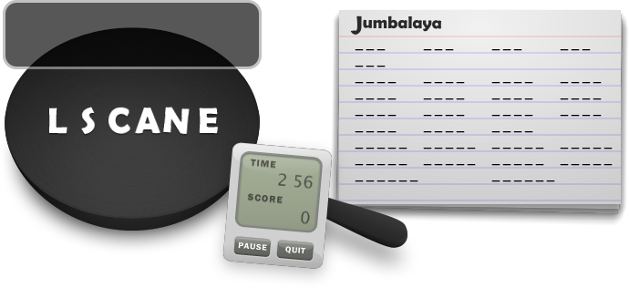
The notecard shows a list of all the words in Jumbalaya’s dictionary that can be made using the letters in the pan. Before you’ve guessed a word, it is shown as a sequence of blanks. Once you’ve guessed a word, it is filled in. You have 3:00 to guess as many words as you can.
In the example above, the word “CANE” is pretty clearly visible. So we could type that in, hit the Enter (Return) key, and voila! It appears in the notecard list. Another (slightly less obvious) word in the set above is the word “SEA.” Note that the letters can appear in any order – however, you can only use a letter once for each time it appears in the pan.
Here’s how our notecard looks now:
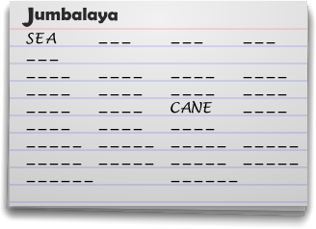

Tip: If typing letters on the keyboard doesn’t seem to work, try clicking on the pan. Sometimes the Widget can lose focus – the pan window needs to have the focus to work properly. You can also simply click on the letters to enter words.
If you get stumped or frustrated, then it’s time to flick the pan! Hit the space bar or click on the pan, and the letters will get sent flying through the air to new positions. This doesn’t affect your score or the time in any way – it’s merely a tool to jog your brain by letting you see the letters (and hopefully, words) in a different way.
If you need a break, click the “PAUSE” button next to the timer. All the words and letters will disappear – no cheating! When you’re done with your break, click the “START” button to continue.
At any time you can click the “QUIT” button to go back to the main menu.

Scoring
You earn points for each word guessed. The score for each word is calculated as 20 points × the number of letters in the word. “SEA” would be 60 points and “CANE” would be 80 points.
You also earn bonus points if you correctly guess all of the words on a notecard. These are worth 10 points per second of time left after you’ve guessed all the words.

Rounds
The more rounds you play, the higher your score will get. However, you need to meet certain conditions to keep on playing into another round.
In EASY mode, you must do at least ONE of the following to advance:
- Guess at least one of the 6-letter words on the list.
- Guess at least 10 words or half of the words on the current list.
In MEDIUM mode, you must do at least ONE of the following to advance:
- Guess at least one of the 7-letter words on the list.
- Guess at least 15 words or 75% of the words on the current list.
In HARD mode, you must do ALL of the following to advance:
- Guess all of the 7-letter words on the list.
- Guess at least 15 words or 75% of the words on the current list.
When a round is over, click on the “Start” button to continue (if you’re given the option).

Options
When you start playing Jumbalaya, you’ll only be dealing with six letters at a time. If you’re interested in a harder style of play, you can go into the Options and change the difficulty to MEDIUM or HARD. Changing the difficulty makes it more difficult to move on to the next round (refer to the Rounds section above), as well as decreases the amount of time for a given round.

Troubleshooting
If you have any issues using the Widget, please sign up on the Konfabulator forums (http://www2.konfabulator.com/forums/) and post a message in the appropriate “3rd Party Widgets” forums.

About the Word Lists
The word lists are based upon the public domain 12dicts word lists, release 4.0. For more information on the 12dicts lists, visit http://wordlist.sourceforge.net/. Words have been rearranged to keep multiple forms of the same word together, and words of questionable vulgarity (according to U.S. English) have been moved to the more difficult categories. If you would like to edit your word lists, you can replace the words.txt file in your Widget’s data folder. The default location of the folder on Windows is:
C:\Documents and Settings\<your username>\Local Settings\Application Data\Yahoo\Widget Engine\
Widget Data\Jumbalaya
and the default location on Macs is
/Users/<your username>/Library/Application Support/Yahoo! Widget Engine/Widgets/Jumbalaya.widget

About the Author
I am a programmer and designer of many things, but mainly (it seems) Widgets and websites. If you’ve enjoyed this Widget, I would really appreciate a PayPal donation sent to james.m.allen@gmail.com. If you’re interested in hiring me to develop a Widget (or anything else, for that matter), please e-mail me at james.m.allen@gmail.com.

